**DocuSign Unit Test**

**Test Scenario 1:**

**Input:** HOT 8, 6, 4, 2, 1, 7

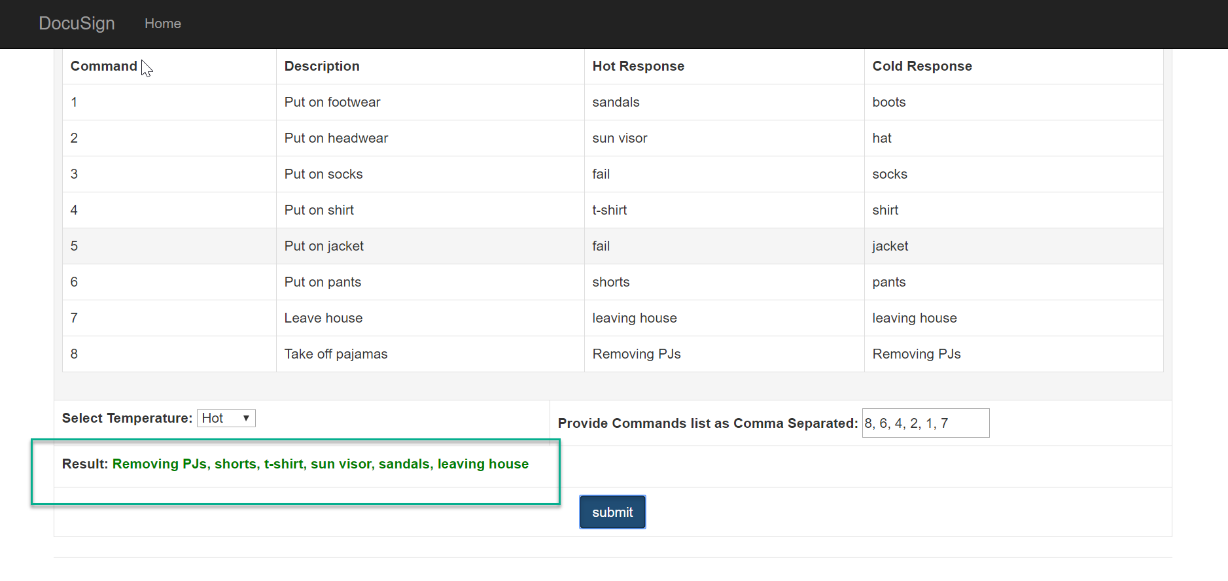

**Test Scenario 2:**

**Input:** COLD 8, 6, 3, 4, 2, 5, 1, 7  
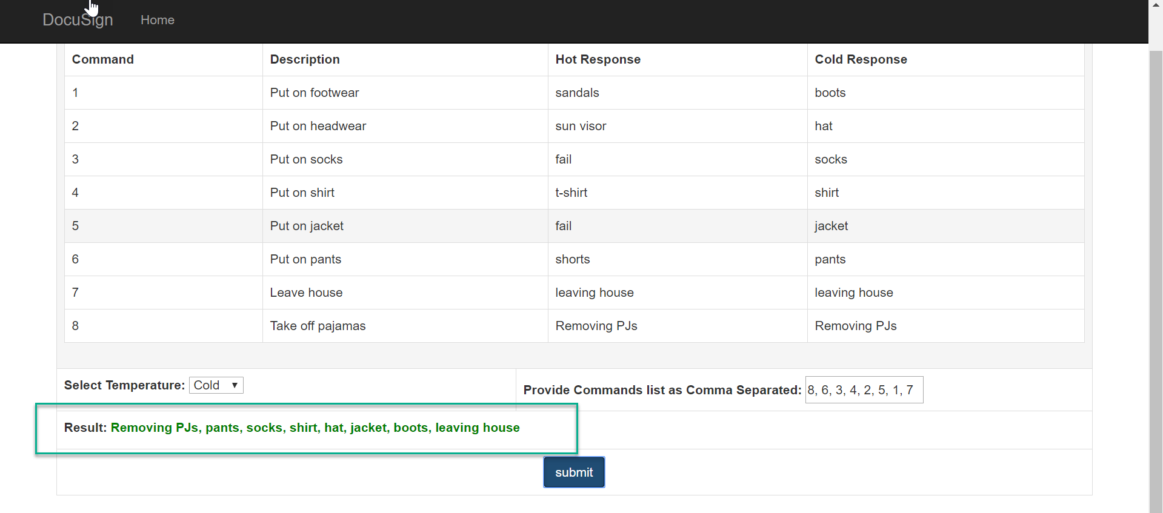

**Test Scenario 3:**

**Input:** HOT 8, 6, 6

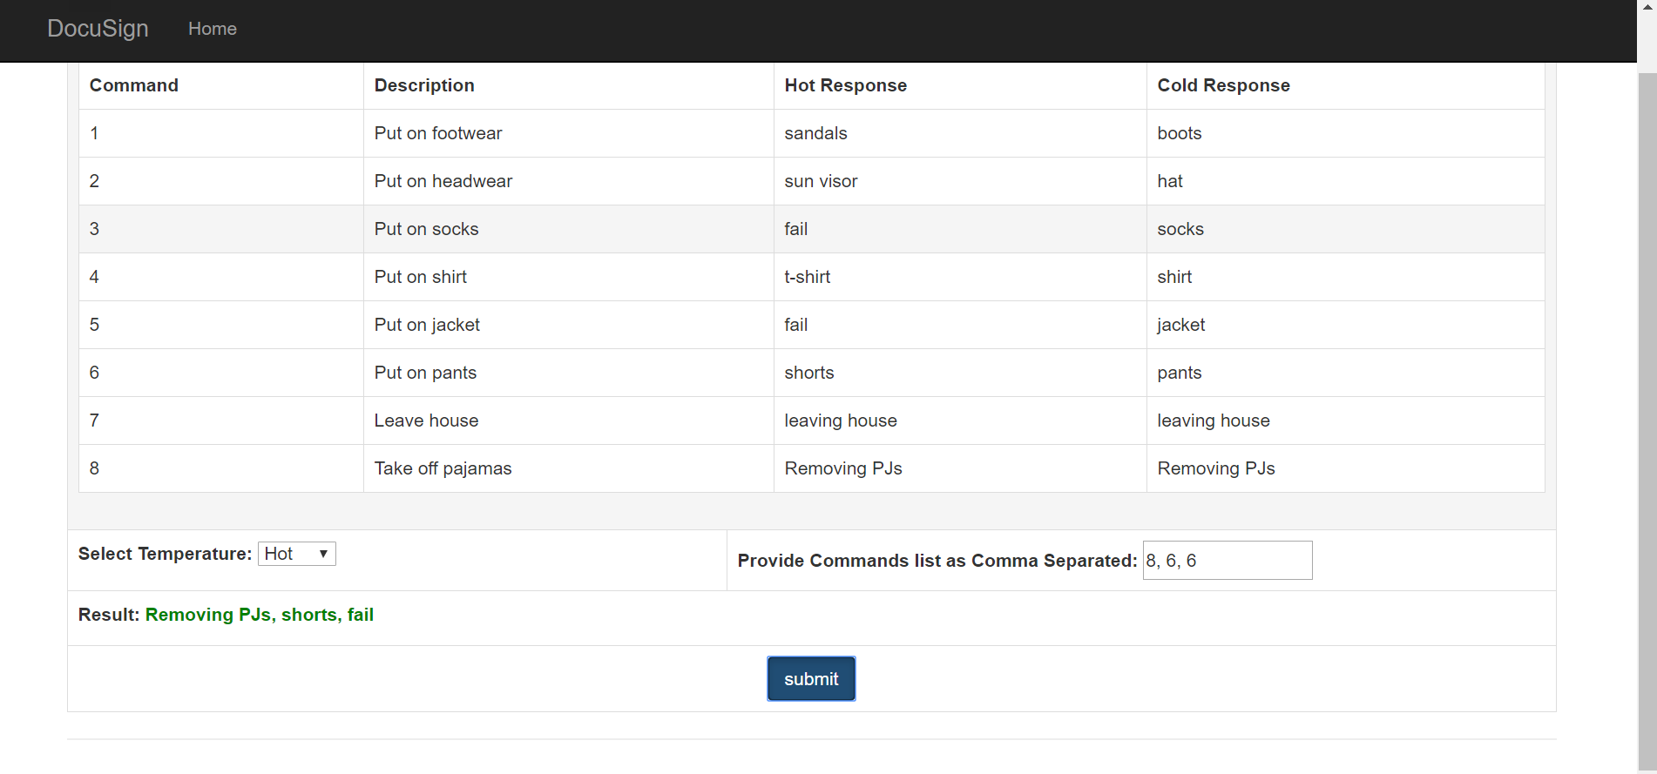

**Test Scenario 4:**

**Input:** HOT 8, 6, 3

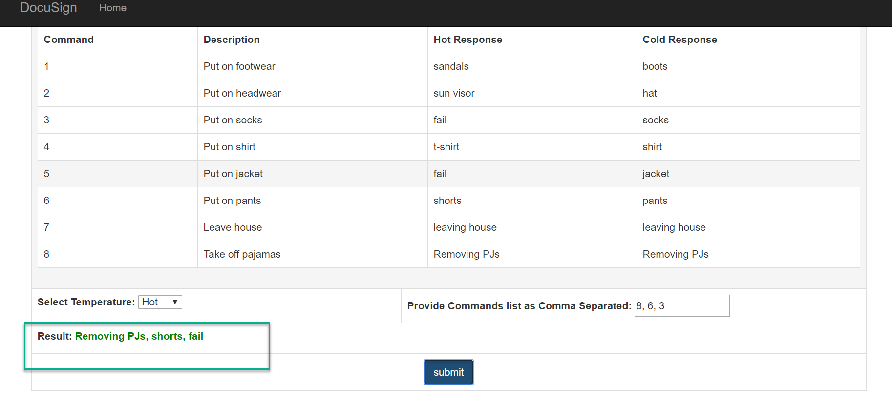

**Test Scenario 5:**

**Input:** COLD 8, 6, 3, 4, 2, 5, 7

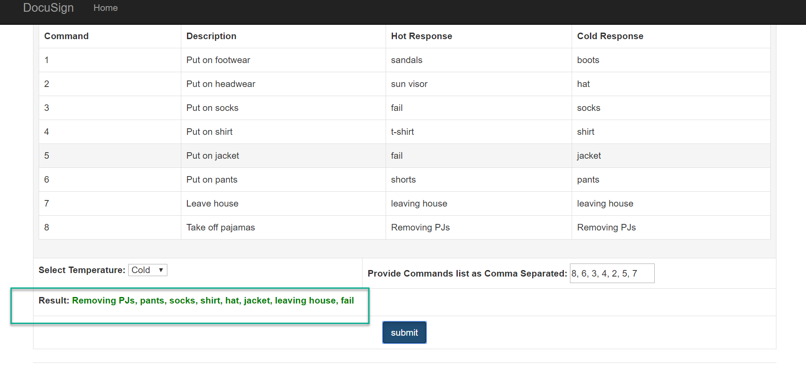

**Test Scenario 6:**

**Input:** COLD 6

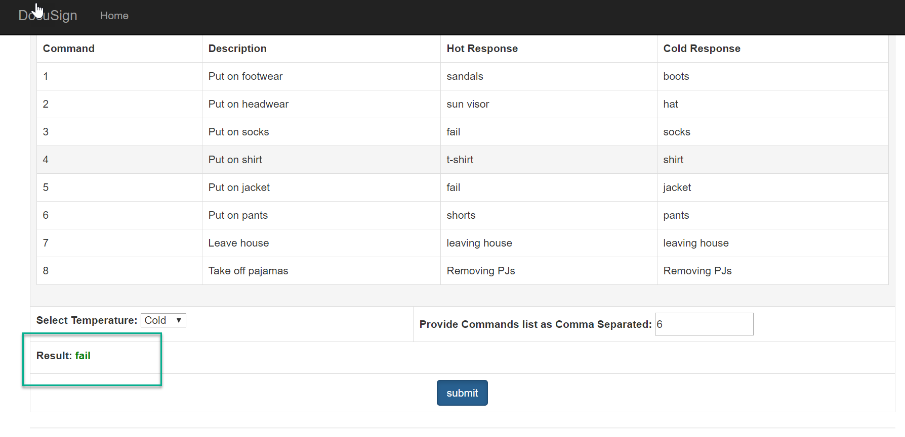

**Test Scenario 7:**

**Input:** COLD 9

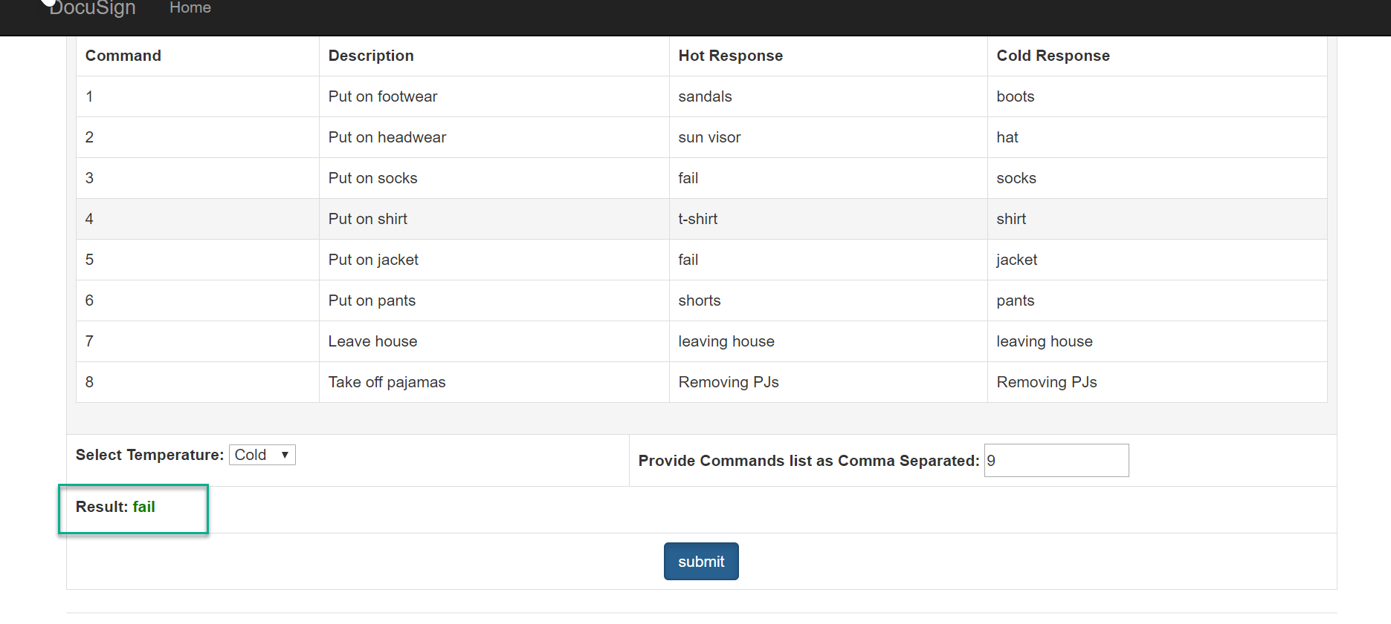

**Unit Test Screenshot**

